Group: C1.036

Sevillano Barea, Alejandro - [alesevbar@alum.us.es](mailto:alesevbar@alum.us.es) Naredo Bernardos, Ignacio- [ignnarber@alum.us.es](mailto:ignnarber@alum.us.es)

Robles Borrego, Adrián - [adrrobbor@alum.us.es](mailto:adrrobbor@alum.us.es)

Sabido González, Francisco Manuel -  [fransabgon@alum.us.es](mailto:%20fransabgon@alum.us.es)

Escudero Aldana, David - [davescald@alum.us.es](mailto:davescald@alum.us.es)

PLANNING AND PROGRESS REPORT

Repository: https://github.com/C1-036/Acme-ANS-D01

February 17th, 2025

Content Table

1. Executive Summary 2

2. Revision Table 3

3. Introduction 3

4. Contents 3

4.1 Planning Chapter 3

4.2 Progress Chapter 3

5. Conclusions 6

6. Bibliography 6

**1. Executive Summary**

This report documents the project's status, including planning and progress. It describes the tasks performed, the resources used, and the development progress. Additionally, it presents performance metrics and a comparison between planning and actual execution.

**2. Revision Table**

|  |  |  |
| --- | --- | --- |
| Revision number | Date | Description |
| 1 | 17/02/2025 | The report was created and completed |
|  |  |  |

**3. Introduction**

This document presents the Planning and Progress Report for the project, specifically prepared for Student 4. It provides a comprehensive record of the project's planning and development so far, detailing the tasks completed, their role within the project, and the individuals responsible for them. Additionally, it compares the estimated and actual time spent on each task.

The report also outlines the methodologies used for task management, ensuring adherence to best practices in execution and documentation. It highlights the main challenges encountered during development and the solutions applied to address them.

Moreover, it includes an initial cost estimation based on allocated work hours and available resources, followed by an analysis comparing estimated and actual costs. Performance indicators are also incorporated to assess efficiency and goal completion, offering a clear perspective on the project's current status and potential areas for improvement in future phases.

**4. Contents**

**4.1** **Planning Chapter**Task List

|  |  |  |  |  |
| --- | --- | --- | --- | --- |
| Task | Description | Responsible person | Planned time | Real time |
| 1 | Modify the anonymous menu to add an option linking to your favourite website's home page with a specific title format. | Francisco Manuel Sabido González | 15 minutes | 6 minutes |
| 2 | Provide a link to your planning dashboard in GitHub to review the tasks, their current status, and your schedule | Francisco Manuel Sabido González | 5 minutes | 5 minutes |
| 24 | Produce an analysis report. | Francisco Manuel Sabido González | 20 minutes | 17 minutes |
| 25 | Produce a planning and progress report. | Francisco Manuel Sabido González | 20 minutes | 28 minutes |

Screenshots of Progress

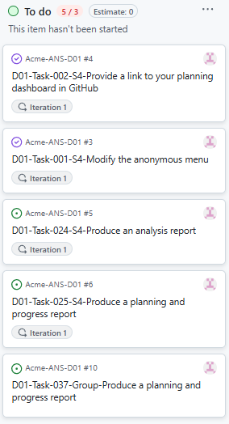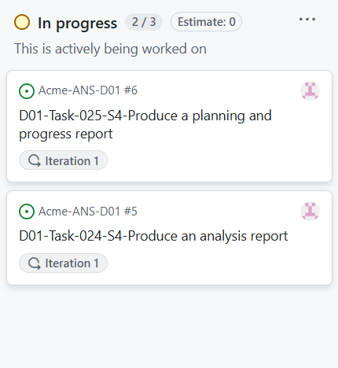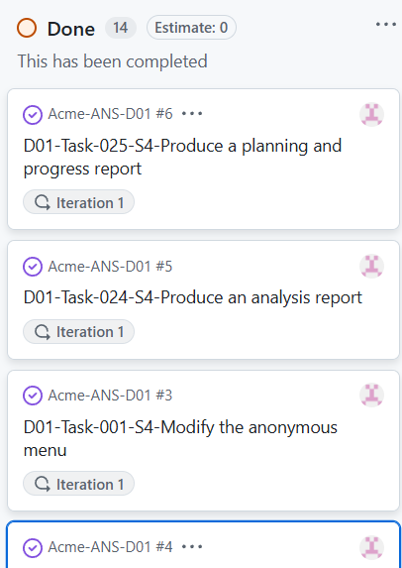

Budget Estimation

|  |  |  |  |
| --- | --- | --- | --- |
| Role | Estimated hours | Hourly cost | Total cost |
| Analist | 1 hour | 30,00€ | 30,00€ |

**4.2** **Progress Chapter**  
Challenges and Resolutions

|  |  |  |
| --- | --- | --- |
| Problem | Description | Solution |
| Intentionally blank |  |  |

### Cost Comparison

|  |  |  |  |  |
| --- | --- | --- | --- | --- |
| Role | Estimated hours | Real hours | Hourly cost | Real cost |
| Analist | 1 hour | 1 hour | 30,00€ | 30,00€ |

**5. Conclusions**

In conclusion, i can say that since this was the first deliverable and primarily consisted of documentation tasks, there is not much to draw conclusions from. The work was mostly focused on setting up the initial structure and ensuring all basic requirements were met, which leaves little room for deeper insights or conclusions at this stage.

**6. Bibliography**

Does not apply